Predictive Maintenance using Car Engine Data

Theodore Sullivan
CIS 568 - Term Paper
April 15, 2024

Abstract:
The automotive industry is undergoing a transformation driven by the need for improved recall management, maintenance operations, and customer satisfaction amidst increasing vehicular complexity and technological advancements. This study addresses these challenges by applying predictive analytics, utilizing vehicle engine health data to inform maintenance strategies, and enhancing operational efficiency proactively. Through comprehensive data analysis, this research pioneers the development of advanced forecasting algorithms employing feature selection and machine learning techniques to predict engine conditions effectively. Notably, the Random Forest Classifier's feature_importances_ attribute was pivotal in identifying critical parameters—engine RPM, fuel pressure, and lubricating oil temperature—streamlining the data for subsequent predictive modeling. This project rigorously evaluated three algorithms: Gradient Boosting, Support Vector Machines (SVM), and Random Forest, demonstrating superior accuracy. This study embodies data science, which contributes to predictive maintenance frameworks and sets a benchmark for future research endeavors in the automotive industry.

1. Introduction
The automotive industry faces multifaceted challenges in efficiently managing recalls, maintenance, and service operations. Automotive companies and dealerships face the daunting task of ensuring vehicle safety, reliability, and customer satisfaction amidst evolving consumer demands and regulatory requirements. The complexity of modern vehicles and the proliferation of technology-driven features exacerbate these challenges, necessitating innovative solutions to streamline operations and enhance customer experience.
Vehicles are being created with more complex structures needing effective maintenance strategies. Three popular strategies are predictive, corrective, and preventive maintenance (Shafi et al.). Predictive analytics using vehicle engine health data emerges as a pivotal tool in addressing these challenges and improving operational efficiency within the automotive sector. By harnessing the wealth of data generated throughout a vehicle's lifecycle, automotive stakeholders can gain actionable insights into potential defects, performance issues, and maintenance needs. This proactive approach enables timely interventions, such as preemptive recalls or preventive maintenance measures, mitigating risks and minimizing disruptions to consumers and industry players.
Leveraging predictive analytics is motivated by its potential to revolutionize how automotive companies and dealerships manage their operations; additionally, this could extend to improving the manufacturing of parts and components. Predictive analytics empowers stakeholders to streamline processes, reduce costs, and enhance customer satisfaction by anticipating maintenance requirements, identifying emerging issues, and optimizing resource allocation.
This project contributes to this transformative shift by leveraging machine learning and data analysis techniques to predict engine failure, given vehicle engine health data. The objective encompasses examining engine health data, complex feature selection methodologies, and predictive modeling techniques to develop accurate forecasting algorithms. This project aims to drive continuous improvement and innovation within the automotive industry by bridging the gap between data analytics and engineering expertise.
1.2 Related Work
In the study, Warranty Claim Rate Prediction Using Logged Vehicle Data, by Khoshkangini et al., the authors developed a machine learning system for predicting warranty claims by integrating Logged Vehicle Data (LVD) and Warranty Claims (WCs) datasets. The LVD dataset, collected from commercial trucks over three years, contained aggregated information about vehicle usage, while the WC dataset captured the history of failures during the warranty period. The authors constructed a predictive model to anticipate warranty claims by merging the two datasets and employing machine learning techniques. They outlined four main modules: Data Integration, Feature Selection, Feature Extraction, and Learning and Prediction. They demonstrated the system’s effectiveness in predicting warranty claims through experimental evaluation, particularly distinguishing healthy and non-healthy vehicles (Khoshkangini et al., 2019).
The authors conducted three experiments to assess the predictive performance of their system. In Experiment 1, they focused on predicting warranty claims within the fuel system, considering both monthly and seasonal variations. Despite some limitations due to unbalanced data, the results showed promising accuracy rates and highlighted the system's potential for early detection of quality issues. In Experiment 2, the authors evaluated the system's ability to identify healthy and unhealthy vehicles, achieving high performance in distinguishing between the two categories. Finally, Experiment 3 explored the value of extracting hidden information from the datasets, leading to significant improvements in predictive performance. Overall, the study demonstrated the effectiveness of integrating machine learning with vehicle usage data for predicting warranty claims and facilitating proactive maintenance strategies (Khoshkangini et al., 2019).

Likewise, a study by Mikulec et al. explored the application of association rule mining techniques to predict and analyze Diagnostic Trouble Codes (DTC) occurrences in automotive systems. Their methodological approach involved collecting a comprehensive dataset comprising distinct Vehicle Identification Numbers (VINs) and their corresponding DTC occurrences sorted chronologically (Mikulec et al., 2017). This dataset provided a rich source of information for identifying patterns and associations among DTC occurrences. Through the application of the A-priori association rule mining algorithm, the authors were able to extract meaningful insights from the dataset. Specifically, they defined support as the frequency of occurrence of item sets (representing DTCs) within the dataset and confidence as the proportion of rules containing certain DTCs in the premise and conclusion. Setting minimum support and confidence thresholds enabled the selection of representative rules relevant to the data and problem statement (Mikulec et al., 2017).
Moreover, the study detailed the process of building a classifier based on association rules to predict future DTC occurrences. By utilizing the same rule structure but with the conclusion containing a class instead of an item, the authors developed a classification model capable of anticipating forthcoming DTCs. The evaluation of machine learning algorithms' performance through train, test, and validation methods provided insights into the predictive accuracy of the models. Notably, the results showed that the random forest prediction model achieved an accuracy ranging from 92% to 98% when validated, demonstrating its efficacy in forecasting one month of forward-looking sales (Mikulec et al., 2017). Additionally, the visualization of model output using tools such as Gantt charts facilitated identifying groups of DTCs with the highest potential for cost savings.
The outline of this paper delineates the main sections and their respective contents, providing a roadmap for the reader. Following this introduction, the paper will delve into the methodology employed in conducting the study, including data collection, preprocessing, and predictive modeling techniques. Subsequent sections will present the project’s expected results and discuss related works in the literature. Finally, the paper will summarize findings, implications for the automotive industry, and avenues for future research.
2. Technical Details
In this section, I’ll discuss the technicalities of creating my predictive model. Data collection and preprocessing involve the initial exploratory data analysis to reach such conclusions. The primary two technicalities are collecting the data and selecting the best features.
2.1 Data Collection and Preprocessing
A substantial volume of data is paramount to developing an effective predictive maintenance model. Furthermore, the data must be accessible for analysis, either through storage or retrieval from networked sources. While data availability may not pose a significant challenge, understanding its structure and performing requisite preprocessing are imperative for model development.
For this study, a dataset sourced from Kaggle was utilized, comprising vehicle engine data. The dataset encompasses seven key parameters: engineer RPM, lubricating oil pressure, fuel pressure, coolant pressure, lubricating oil temperature, and the target variable, engine condition. Notably, the dataset comprises 19,535 instances, each characterized by numeric attributes. The absence of categorical data simplifies preprocessing efforts, negating the need for encoding techniques that would otherwise be necessary.
Upon preliminary inspection, the dataset revealed no missing values, alleviating the need for imputation or column removal. However, a more nuanced exploration was warranted to discern underlying patterns and relationships between variables. Visual aids such as pair plots and correlation heatmaps were employed.
2.1.1 Pair Plot and Correlation Heatmap Analysis:
The pair plot visualization revealed no discernible linear relationships between variables, as depicted in Figure 1.1 below. Additionally, in Figure 1.2, the correlation heatmap failed to identify strong correlations between features, further complicating the feature selection process. This absence of evident correlations left me without clear guidance regarding which features might hold the most predictive value.
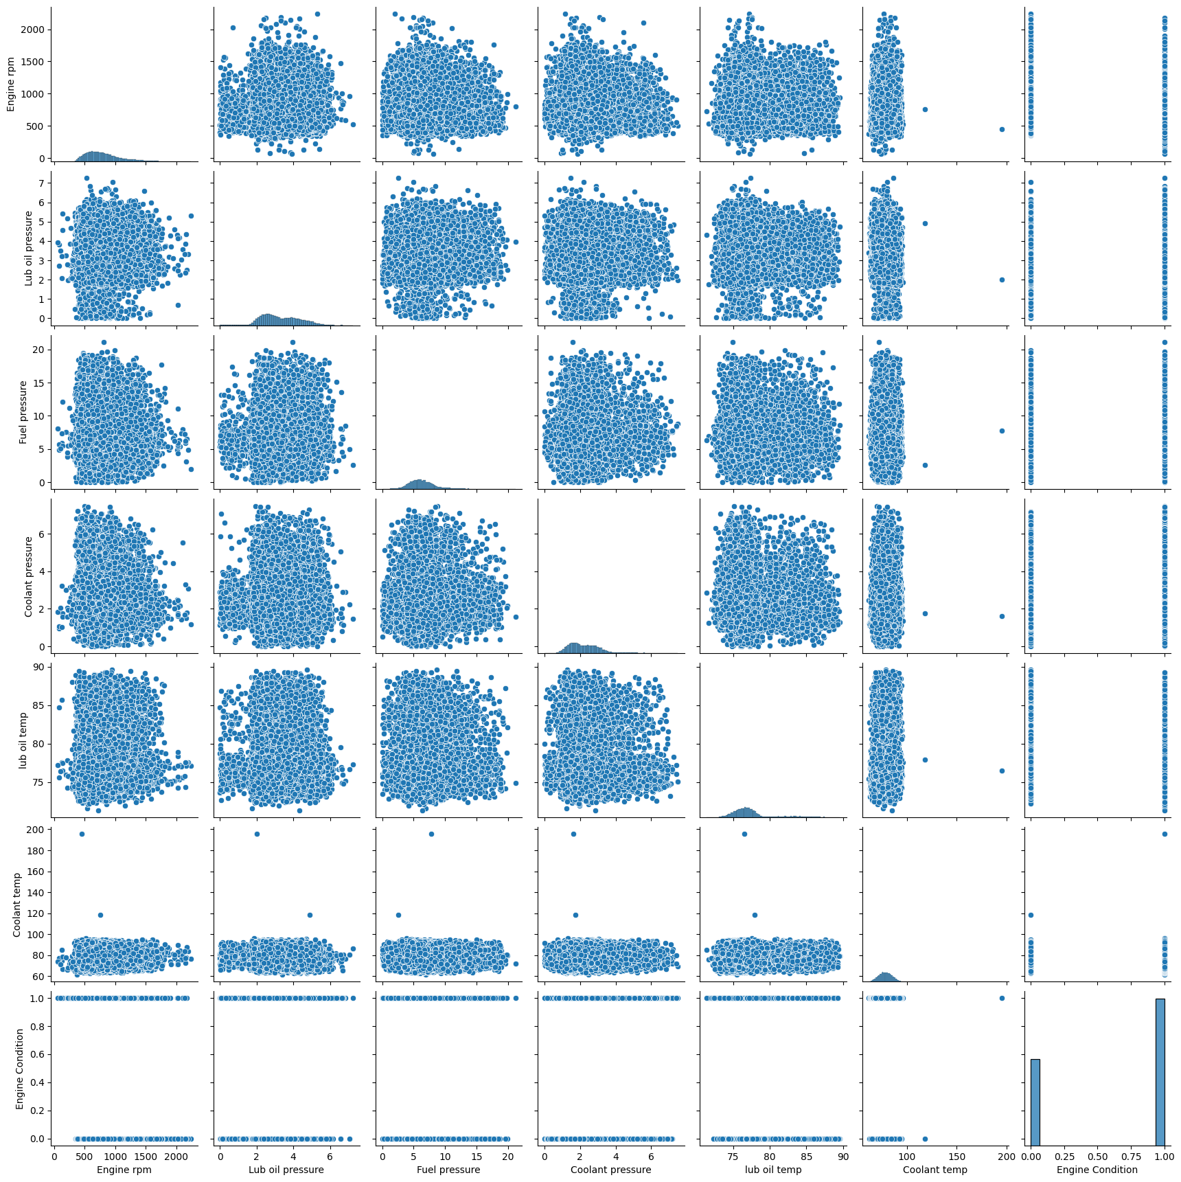
Figure 1.1 Pairplot depicting the relationship between variables
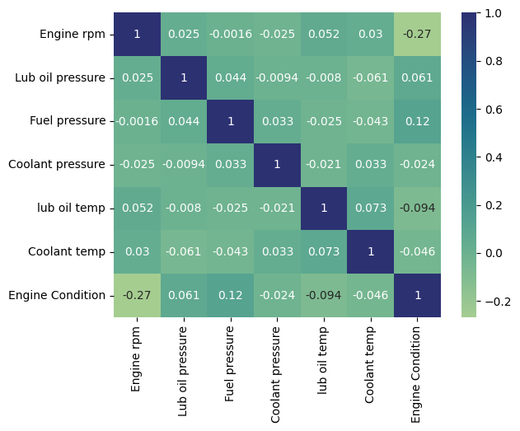
Figure 1.2 Correlation heatmap depicting the correlation between variables
In preparation for modeling, it was imperative to standardize the feature values to a uniform scale. The MinMaxScaler was employed to achieve this. MinMaxScaler is a normalization technique that scales and transforms each feature's values to fit within the range of 0 to 1. This ensures that all features contribute equally to the model's learning process, regardless of their original scale or magnitude.
2.2 Feature Selection
Feature selection plays a pivotal role in developing predictive models, as it involves identifying and prioritizing the most informative attributes for accurate predictions. This study chose a Random Forest Classifier as the feature selection method because of its efficacy in handling non-linear data and discerning important features.
The Random Forest Classifier operates by constructing an ensemble of decision trees, each trained on a random subset of the data and features. By aggregating the predictions of multiple trees, the classifier can effectively capture complex relationships between features and the target variable (Wikipedia, 2024). Additionally, the "importance" attribute of the Random Forest Classifier provides a metric for ranking features based on their predictive significance, aiding in the feature selection process.
Hyperparameter tuning is essential to optimize the performance of the Random Forest Classifier. GridSearchCV, a powerful tool provided by the scikit-learn library, automates this process by exhaustively searching through a specified parameter grid and evaluating model performance using cross-validation. By systematically varying hyperparameters such as the number of estimators, maximum depth, and minimum samples per leaf, GridSearchCV identifies the optimal configuration that maximizes model performance on unseen data.
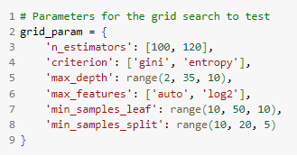
Figure 2.1 Parameters for GridSearchCV used to optimize the model for feature selection
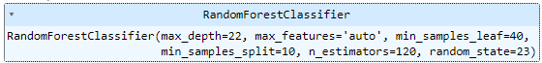
Figure 2.2: The Optimal Hyperparameters Identified by GridSearchCV fitted to the new Random Forest model
By leveraging GridSearchCV in conjunction with the Random Forest Classifier, I systematically explored a wide range of hyperparameter combinations and identified the optimal tuning of the parameters. After configuring the model with the best parameters and using the random forest classifiers attribute, feature_importances, I could see an evident distinction between the top three features: engine RPM, fuel pressure, and lubricating oil temperature. Thus, I will only use those features for my predictive models. This is seen below in Figure 2.3.
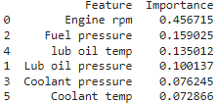
Figure 2.3 Results of feature importance attribute from Random Forest classifier (scikit-learn)

3. Methodology
This section will outline the methodology for developing and evaluating the predictive maintenance model. The methodology encompasses algorithm selection, model planning, code implementation, and hypertuning of the model. Again, to accomplish this, I used a reduced dataset, only using the most important three features. Likewise, the dataset was resplit into an 80/20 training and testing set for each model.

3.0.1 Algorithm Selection:
The selection of appropriate algorithms forms the cornerstone of our predictive maintenance model. Three distinct algorithms were chosen for evaluation: Gradient Boosting, Support Vector Machines (SVM), and a Random Forest for comparative analysis. Each algorithm was selected based on its suitability for handling non-linear data and its potential to deliver robust predictive performance.
Gradient Boosting: Gradient Boosting is a powerful ensemble learning technique that sequentially builds a series of weak learners, with each subsequent learner focusing on the errors of its predecessors (Saini, 2024). Its ability to minimize loss functions and optimize predictive accuracy makes it an ideal candidate for a predictive maintenance model.
Support Vector Machines (SVM): SVM is a versatile machine learning algorithm renowned for its effectiveness in classification tasks, particularly in scenarios with complex decision boundaries. By transforming input data into higher-dimensional space and identifying an optimal hyperplane, SVM can effectively discriminate between different classes, making it well-suited for predictive maintenance applications (Prema, 2023).
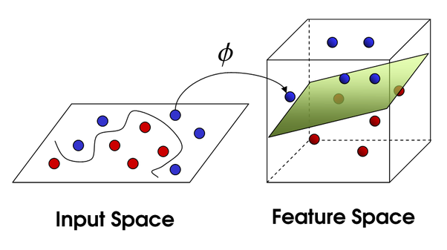
Figure 3.1 A visual representation of Support Vector Machines,https://cml.rhul.ac.uk/svm.html
3.1 Predictive Modeling
This section will outline the predictive models used to predict engine failure. This details the libraries and hypertuning of each model/algorithm. The three models used were Random Forest, Gradient Boost, and Support Vector Machines, suitable for smaller, non-linear datasets and typically more accurate models.
As mentioned in 2.2, the initial dataset has been reduced to include only the top three parameters identified through the Random Forest classifier: engine rpm, fuel pressure, and lubricating oil temperature. These features were chosen based on their contrasted significance in predicting the target variable, indicative of their critical role in forecasting engine failure. Engine rpm is a fundamental indicator of engine operation, while fuel pressure and lubricating oil temperature are pivotal metrics reflecting the engine's fuel and lubrication systems' integrity, respectively.
Reducing the dataset to include only the top three parameters stemmed from a multifaceted rationale to enhance the modeling process. By focusing on a select set of influential features, we aimed to mitigate the complexity of the model, facilitate interpretability, and improve predictive performance. This deliberate refinement aligns seamlessly with the overarching objective of developing a robust predictive maintenance model that effectively identifies and addresses potential machinery failures.
3.1.1 Random Forest Classifier
The Random Forest model serves a dual purpose in this study: it acts both as a feature selection tool and a predictive model. As depicted in Figure 2 (refer to the visual representation in the appendix), the Random Forest algorithm constructs numerous decision trees to identify the most informative features and make accurate predictions based on the input data.
The decision to utilize Random Forest as a predictive model stems from its ability to efficiently handle high-dimensional datasets and provide immediate feedback on the efficacy of dimensionality reduction techniques. Moreover, employing a Random Forest facilitates comparing model performance under varying parameter settings.
A GridSearchCV approach is employed twice to optimize the performance of the Random Forest model. The first iteration assists in identifying initial parameter configurations, while the second iteration, despite featuring some parameter differences, aims to fine-tune the model. Notably, although parameter adjustments are made during the second GridSearchCV run, the observed variance in accuracy remains minimal.
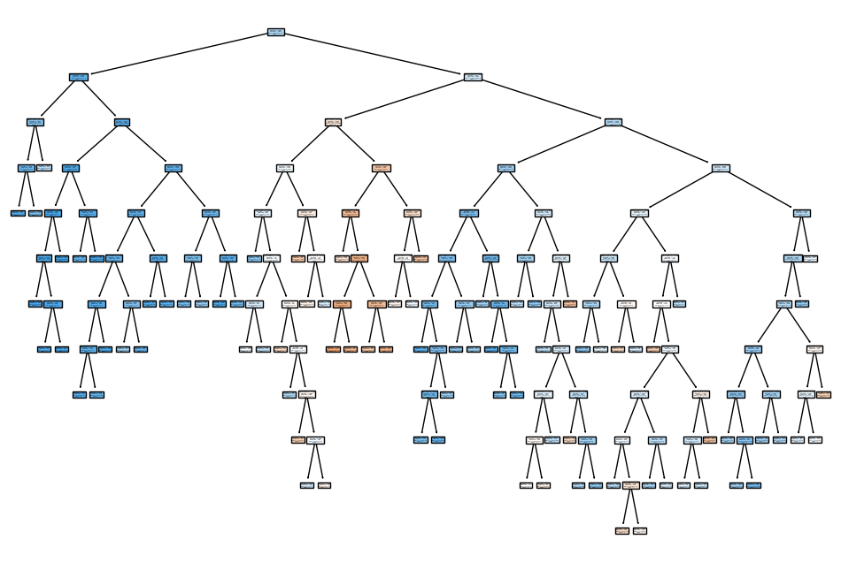
Figure 3.1 Random Forest model generated to classify engine failure
This methodology allows for a comprehensive exploration of Random Forest's feature selection and predictive modeling capabilities, providing insights into the effectiveness of dimensionality reduction techniques and parameter tuning strategies.
3.1.2 Gradient Boost
Like the Random Forest model, the Gradient Boosting Classifier is employed as both a feature selection tool and a predictive model. Following the initial filtering of the engine dataset to retain only the top three features, the Gradient Boosting Classifier is trained to assess its performance in predicting engine conditions.
Initially, the dataset is split into training and testing sets, and features are scaled using MinMaxScaler to ensure consistency in model training. The Gradient Boosting Classifier is then initialized and fitted to the training data.
A GridSearchCV approach is employed twice to optimize the model’s performance. The first iteration aims to identify initial parameter configurations, including the number of estimators, learning rate, and maximum depth. Despite slight variations in accuracy compared to the Random Forest Classifier, the initial GridSearchCV run provides insights into potential parameter adjustments.
Subsequently, a second GridSearchCV iteration is conducted to fine-tune the model further. This iteration explores a narrower range of parameter values to identify the optimal structure. Although the overall accuracy remains consistent, the refined parameters contribute to a marginal increase in accuracy.
It is worth noting that the dataset exhibits class imbalance, with more instances of one class compared to the other. This imbalance may influence model performance and requires careful consideration during interpretation.
The confusion matrix visualization provides a comprehensive overview of the model's predictive performance, allowing for the assessment of true positive, true negative, false positive, and false negative predictions.
3.1.3. Support Vector Machines
This study utilizes the support vector machine (SVM) Classifier to perform feature selection and predictive modeling tasks. Like the Random Forest and Gradient Boosting models, the SVM Classifier undergoes a series of steps to optimize its performance.
Initially, the engine dataset is filtered to retain only the top three most relevant features. Subsequently, the dataset is split into training and testing sets, and features are scaled using MinMaxScaler to ensure uniformity in model training. The SVM Classifier is then initialized and trained on the training data using default parameters. Following this, an initial evaluation of the model's accuracy is conducted.
A GridSearchCV approach tunes hyperparameters to enhance the SVM Classifier’s performance. The GridSearchCV iterates over various combinations of hyperparameters, such as regularization parameter (C), kernel type, and gamma value, to identify the optimal configuration. The best parameters are obtained despite encountering some fits that failed during the GridSearchCV process.
Using the best parameters identified through GridSearchCV, an optimized SVM Classifier is generated and evaluated on the testing set. While the optimized model demonstrates an increase in accuracy compared to the initial model, it does not achieve the highest accuracy attained by other classifiers. The confusion matrix visualization provides insight into the SVM Classifier's predictive performance, illustrating the distribution of true positive, true negative, false positive, and false negative predictions.
4. Results
The comparative analysis of three machine learning models – Random Forest, Gradient Boosting, and Support Vector Machine (SVM) classifiers – offers valuable insights into their capabilities in engine condition prediction. The Random Forest Classifier achieved the highest accuracy among the evaluated models, scoring 67.52%. Notably, its ability to predict instances of the non-failure class, non-failure condition, is hindered by low recall values, suggesting a higher number of false negatives, which could lead to undetected engine problems in a practical setting. See Figure 4 below for the model results via a confusion matrix and classification table.
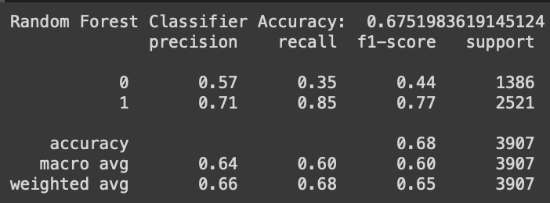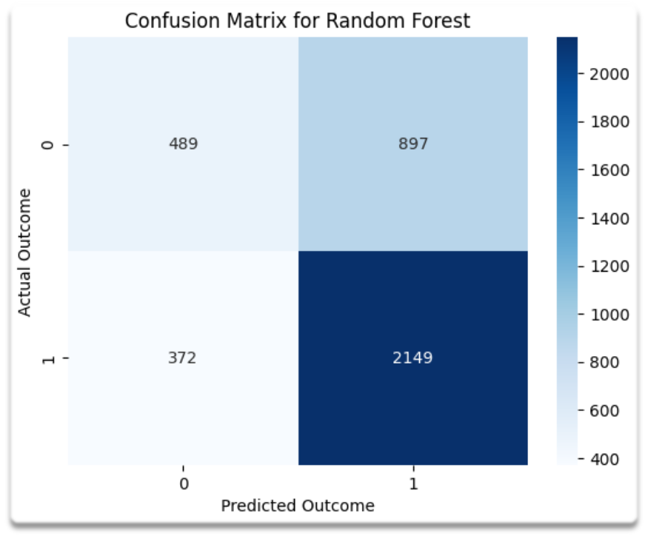
Figure 4.1 Gradient Boost Confusion matrix followed by classification report
The Gradient Boosting Classifier demonstrated competitive performance with an accuracy of 66.27%. While it was marginally less accurate than the Random Forest Classifier, it displayed an improved recall for both classes compared to the SVM, which indicates its relative strength in correctly identifying positive samples. This attribute is particularly valuable in predictive maintenance contexts where failing to detect problematic conditions could have costly consequences. See Figure 5 below for the model results via a confusion matrix and classification table.

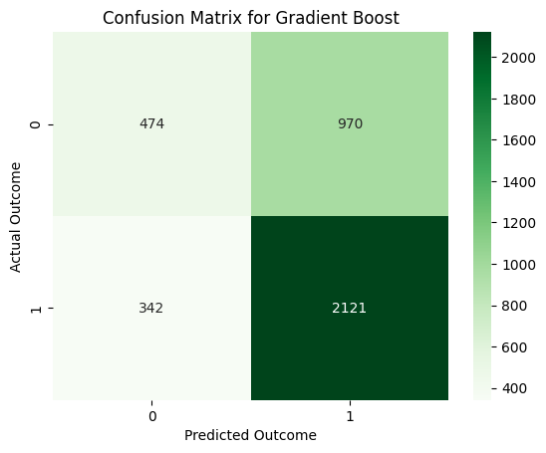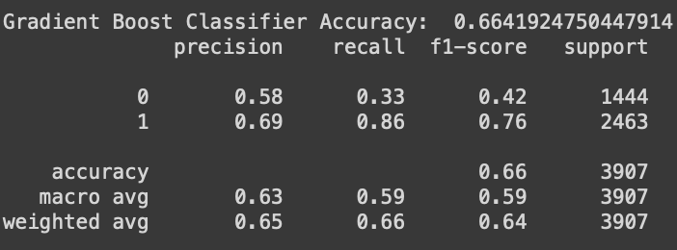
Figure 4.2 Gradient Boost Confusion matrix followed by classification report
The SVM Classifier, with an accuracy of 65.75%, displayed moderate performance. Like the Random Forest Classifier, the SVM struggled with accurately identifying the non-failure class instances, as reflected by a low recall value for this class. This suggests that while the SVM is conservatively minimizing false-positive rates (engine conditions wrongly identified as problematic), it risks missing actual engine problems, which is a significant concern in preventive maintenance strategies. See Figure 6 below for the model results via a confusion matrix and classification table.
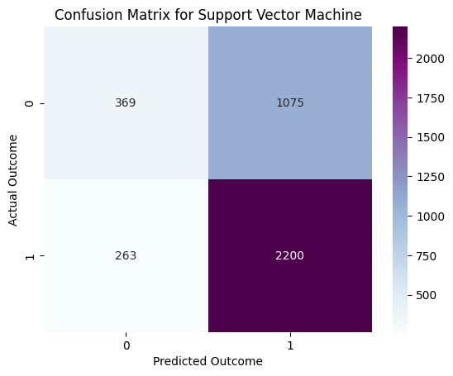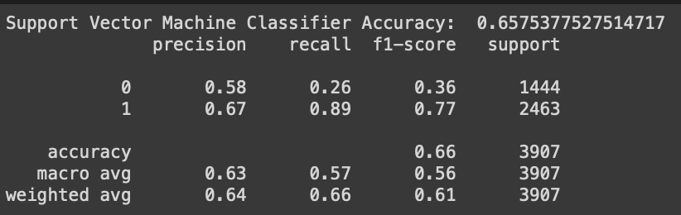
Figure 4.3 SVM Confusion matrix followed by classification report
The performance metrics provide insight into the balance between precision and recall achieved by each model: The Random Forest tends towards higher precision, especially for class 1, the failure condition, suggesting a lower false-positive rate but at the cost of a higher false-negative rate, as indicated by its recall; the Gradient Boosting Classifier, while offering a balanced performance, still shows room for improvement in precision for the non-failure class. The SVM prioritizes correctly identifying the failure class over the non-failure class, resulting in many missed non-failure condition predictions.
In conclusion, while each model presents distinct prediction capabilities, critical to the success of any predictive maintenance program is not merely accuracy but the ability to make reliable predictions across all conditions. Consequently, future work must optimize the balance between precision and recall, reduce classification biases, and prioritize detecting all relevant engine conditions to minimize the risk and cost associated with engine failures.
5. Conclusion
This section will discuss the results of each model and the concluding thoughts on the overall analysis. Last, it’ll include ideas for future research.

5.1.1 Concluding Thoughts
This study highlights the critical importance of selecting appropriate machine learning algorithms and fine-tuning hyperparameters to predict engine failure in a vehicle accurately and in generalizability. Although each model exhibits its strengths and limitations, there is a clear need for additional refinements to overcome issues such as class imbalance and low recall scores. One significant hurdle encountered was the difficulty in sourcing comprehensive datasets for predictive maintenance – a richer dataset with more features and data points could potentially enhance the results noticeably.
Furthermore, despite efforts to address the prevalent class imbalance through stratified k-folds in grid search cross-validation, there remains potential for exploring more sophisticated methods to mitigate this imbalance. Observations in the results indicate a potential area of focus for future improvements in the models' abilities to make balanced predictions across both classes. In conclusion, while this analysis has contributed to predictive maintenance within the data science community, I recognize considerable scope for further improvement and development.
5.1.2 Future Work
Future research will focus on combining strategies of multiple machine-learning prediction models to achieve greater predictive performance than any single model alone. By leveraging the diverse perspectives of different classifiers, it is anticipated that more accurate and robust outcomes can be produced. Moreover, future investigations will prioritize procuring more comprehensive and higher-quality datasets. With access to more robust data, the research will undertake the development of advanced feature engineering and selection techniques. The aim will be to identify and construct an optimal set of predictive features, thereby enhancing the models' ability to make accurate predictions. The concerted effort to refine features, optimize model combinations through ensemble methods, and utilize superior data will pave the way for more precise and dependable results in future studies. Lastly, exploring ways to help each model be more balanced across the classes would benefit the analysis results.

References:
- Blischke, W.R., Rezaul Karim, M., Prabhakar Murthy, D.N. (2011). Use of Warranty Data for Improving Current Products and Operations. In: Warranty Data Collection and Analysis. Springer Series in Reliability Engineering. Springer, London. https://doi.org/10.1007/978-0-85729-647-4_15
- Jeon, Jeasu, and So Young Sohn. "Product failure pattern analysis from warranty data using association rule and Weibull regression analysis: A case study." Reliability Engineering & System Safety, vol. 133, 2015, pp. 176-83. ScienceDirect, https://doi.org/10.1016/j.ress.2014.08.015.
- Khoshkangini, R., Pashami, S., Nowaczyk, S. (2019). Warranty Claim Rate Prediction Using Logged Vehicle Data. In: Moura Oliveira, P., Novais, P., Reis, L. (eds) Progress in Artificial Intelligence. EPIA 2019. Lecture Notes in Computer Science(), vol 11804. Springer, Cham. https://doi.org/10.1007/978-3-030-30241-2_55
- Mikulec, Nick, et al. "Analysis of Warranty Data to Identify Improvements to Vehicle Reliability and Service Information." SAE International Journal of Passenger Cars - Electronic and Electrical Systems, vol. 10, no. 2, Aug. 2017. Gale Academic OneFile, link.gale.com/apps/doc/A531111149/AONE?u=lom_umichdearb&sid=googleScholar&xid=74c82710. Accessed 4 Mar. 2024.
- Modi, Parv. "Engine Health Data." Kaggle, Year of publication. Web. Accessed 30 March 2024. https://www.kaggle.com/datasets/parvmodi/automotive-vehicles-engine-health-dataset/data.
- Prema, Prema. "Understanding Support Vector Machines (SVM) in Machine Learning." LinkedIn, https://www.linkedin.com/pulse/understanding-support-vector-machines-svm-machine-learning-prema-p. Accessed 2 April 2024.
- Saini, Anshul. "Gradient Boosting Algorithm: A Complete Guide for Beginners." Analytics Vidhya, Analytics Vidhya, 10 Jan. 2024, www.analyticsvidhya.com/blog/2021/09/gradient-boosting-algorithm-a-complete-guide-for-beginners/#:~:text=What%20is%20Gradient%20Boosting%3F,%2C%20typically%20decision%20trees%2C%20sequentially. Accessed 2 Apr. 2024.
- Scikit-learn: Machine Learning in Python, Pedregosa et al., JMLR 12, pp. 2825-2830, 2011.
- Wikipedia contributors. "Random forest." Wikipedia, The Free Encyclopedia. Wikipedia, The Free Encyclopedia, 22 Mar. 2024. Web. 1 Apr. 2024.

